AWS UPLOAD

1. Get Bluetooth Mac Address
2. Log into AWS. Go to Service -> S3

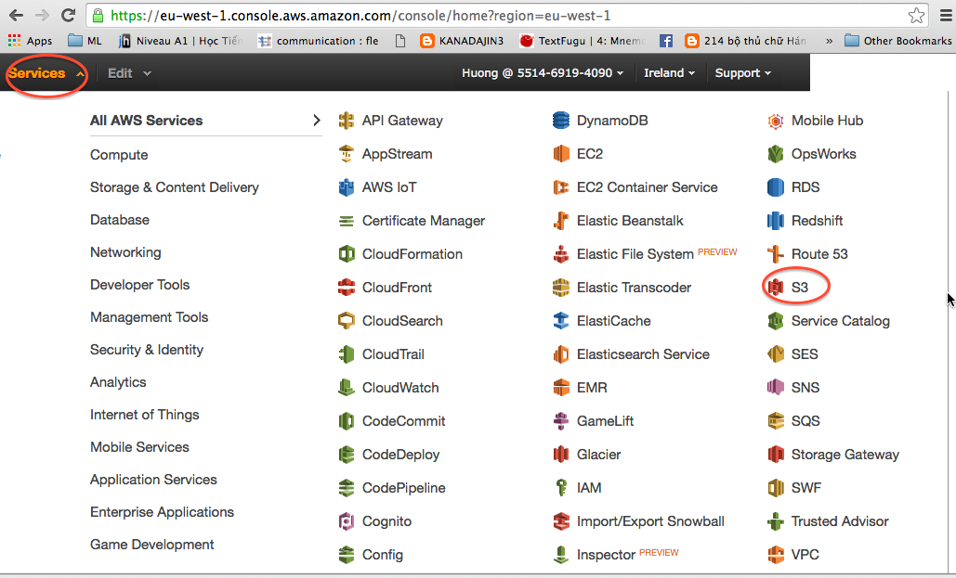

1. Add access for Bluetooth device
   1. Select **hwaccess** bucket

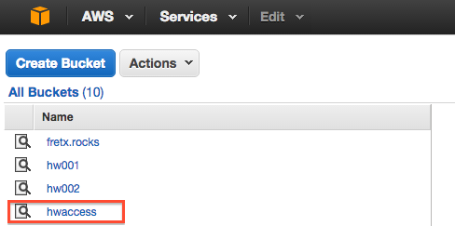

* 1. Select file **hwbucketmapping.csv**. Download to your local computer

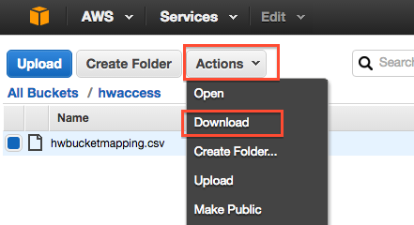

* 1. Open file with Notepad or similar text edit program (Excel should not be used). Enter your Bluetooth device in the following format:

**<Bluetooth MacAddress>,<AWS bucket>**

Ex: 20:15:06:12:07:47,hw003

Currently, all devices should be mapped to bucket hw003.

**Note**: *DO NOT REMOVE the first line of the file (NOBTDEVICE,hw001). This is used to show the list of videos when no Bluetooth device is connected.*

* 1. Save and Upload **hwbucketmapping.csv** back to AWS S3.

1. Upload new text files (Chord files)

4.1 Name text file in the following format:

**<Display name>.<Youtube ID>.txt**

Ex: Led Zeppelin - Immigrant Song.TlmrQfSTmiY.txt

**Note:** *Youtube ID can be extracted from youtube URL. Open the song in Youtube to get the song ID.*

[*https://www.youtube.com/watch?v=****eTNitq77Utg***](https://www.youtube.com/watch?v=eTNitq77Utg)

4.2 Upload text file to AWS (currently bucket hw003 should be used)

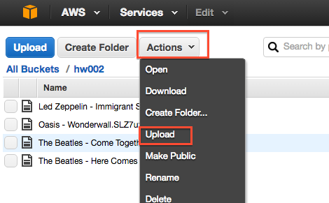

Add Files -> Start Upload

